OFG-5910 Gas Open Fryer (with pump)

Gas Open Fryer

INSTRUCTION MANUAL

Read this manual carefully prior to use.
Technology is subject to change without notice.

Gas open cooker safety precautions
To prevent personal injury, electric shock, fire, or machine failure, please be sure to observe the following precautions:
Before using this machine, please read this instruction manual carefully and keep it in a safe place for reference during use or when inquiring.
Please read carefully and fully understand the symbols and warning signs marked on the machine, and strictly abide by them.
Notes on warnings, cautions, and notes in the manual and on the machine.
Warning Ignoring this mark and performing incorrect operation may result in personal injury, death or fire.
Caution Ignoring this mark and performing incorrect operation may result in personal injury.
Take care Ignoring this mark and performing incorrect operation may cause the machine to malfunction and affect its performance.
Warning
- Please be sure to use a power air switch that matches the power of the machine.
- Please do not touch the power cord with wet hands to avoid electric shock.
- Do not place the power cord on tables, chairs or other hard pressure facilities, especially in places with sharp edges where metal is squeezed, as this can easily damage the power cord. Do not lay the power cord in the aisle.
- Before using or powering on or heating, you must first add liquid cooking oil into the pot. The oil level should be higher than the lowest "MIN" oil level line, but not higher than the highest "MAX" oil level line. Ignoring this will cause equipment accidents and personal safety.
- Keep away from flammable and explosive items and places with open flames.
- It should be noted that overly wet food or excessive loading may cause excessive boiling, resulting in oil overflow or splashing, causing dangers such as burns.
- Do not add too much food at one time, the amount should be appropriate to prevent oil spills and fire.
- Do not use old oil for frying as this will lower the flash point and make overboiling more likely.
- During the frying process, make sure the lid is locked tightly to prevent the pressure from causing the lid to pop open and cause danger.
- WARNING: Do not open the drain tap or other venting device until the pressure has been reduced to near atmospheric pressure.
- The power cord should be oil-resistant flexible sheathed cable, not lighter than ordinary chloroprene rubber or other equivalent synthetic rubber sheathed soft wire [designated brand GB/T5013.1 (IEC 60245, IDT) No. 57 wire]. The wire diameter should meet the power requirements. If the power cord is damaged, it must be replaced by professionals from the manufacturer, its maintenance department or similar departments to avoid danger.
- The power lead in front of the socket or switch must meet the power requirements of the machine, and confirm whether the power connection line can withstand the maximum current of all equipment. If the current used exceeds the capacity of the power lead, it may cause a fire.
- Do not open the cover of the electrical box. If it needs to be opened, ask a qualified electrician to do it to avoid the risk of injury or death.
- The waterproof grade of this device is IPX4. It is strictly forbidden to immerse it in water or use water jets to rinse it. Otherwise, the machine will be seriously damaged and personal injury or death may occur.
- The oil temperature must not exceed 200℃, otherwise fire may easily occur and seriously affect food hygiene and safety.
- The power supply voltage used by the equipment must match the voltage on the product nameplate. The allowable voltage fluctuation is +5%--10%. If this is ignored, the equipment will not function properly.
Warning
- If using a power plug, it should maintain good contact when inserted into the socket, otherwise it may cause a fire.
- To prevent accidents, unplug the power plug during thunderstorms or when the machine is not in use.

- When unplugging the plug, use dry hands. Do not pull the power cord to avoid breaking the wire.
- The equipotential connection terminal of this equipment is It is located at the rear and lower part of the machine. If multiple electrical devices are used at the same time, they must be connected to each other to avoid potential differences that affect safety.
- Equipotential symbol Meaning: It refers to terminals that are connected to each other so that all parts of a device or system reach the same potential, which is not necessarily the ground potential, such as local interconnect lines.
- When connecting, removing or unplugging, disconnect the external main power supply first.
- Before starting the machine, check the connection or control of each electrical component.
- Only personnel holding an electrician's license should be hired for installation, electrical connection, and maintenance.
- Maximum food loading at one time: 8.4 kg
- If the oil level falls below the minimum marking, there is a risk of fire.
Take care
- After burning and heating, do not touch the fryer with your hands to avoid burns.
- This device must be protected from rain and moisture.
- It should not be placed in a corrosive place, should be prevented from severe vibration, and should not be inverted.
Take care
Installation Notes
Please do not install or store this device in the following locations to avoid malfunction caused by misoperation:
- On an unstable table or counter.
- There are flammable and explosive items around.
- Places with too high or too low temperature, too high humidity, or too much dust.
- Places where the power supply voltage is very unstable.
- Where there is no good grounding device.
- Places within the reach of children or minors and persons with reduced physical senses.
- Pay attention to environmental pollution and install a smoke exhaust device where the fryer is installed .
Take care
Operation Notes
- It should be operated by designated personnel, who should be on when the machine is turned on and off when the machine is not in use, and should be proficient in the use of the machine.
- This instruction manual is not intended for people (including children) with reduced physical, sensory or intellectual capabilities, or lack of experience and knowledge.
- When the fryer is working, customers are not allowed to touch it to avoid burns!
- Be careful when moving the machine, and look for faults carefully if you encounter any, and do not knock it.
- There are hook handles on the left and right sides of the frying basket. When frying is completed, use the handles to lift the frying basket and hang it on one side of the pot to filter out excess oil.
- The maximum working temperature of this oil pan is 190 ℃ . When the equipment fails and the oil temperature exceeds 230 ℃ , the over-temperature protector (temperature limiter) in the electrical box will be activated and the combustion gas source will be automatically cut off. This protector is a manual reset structure. Only when the fault is eliminated and the oil temperature cools down to below 150 ℃ , can the reset button on the over-temperature protector be pressed manually to re-energize and heat.
Caution
Things to note when a malfunction or abnormal situation occurs
- If a malfunction or abnormal situation occurs, please stop using the device, disconnect the power supply, contact the original sales office as soon as possible, and tell them the name, model, fault status and other details of the equipment so that it can be resolved in time.
- Please do not use the equipment when it is in an abnormal state, do not disassemble or repair it by yourself. Except for the daily maintenance specified in the manual, other maintenance and debugging should be performed by qualified personnel to avoid electric shock or major malfunctions.
- If oil leakage is found, stop using the machine immediately, contact the dealer quickly or ask someone with maintenance experience to repair it.

- Features and uses
OFG-5910 series gas open fryer is the latest product of our company that has been innovated by introducing advanced foreign products. This machine uses gas as the heating source, and the temperature, pressure, and time are all digitally controlled automatically. It has electronic ignition, always open flame standby, and automatic heating control through a gas controller, which is safe and reliable. It adopts a special internal combustion tube heating method, with a simple structure, economical and practical, sufficient firepower, and the effect is equivalent to that of an electric pressure fryer. It is especially suitable for use in occasions without a three-phase high-power power supply. It is used to fry poultry such as chickens and ducks and fried foods, which is completely comparable to electric open fryers, and can greatly save energy consumption and production costs .
- Main technical parameters
  - Model: OFG-5910
  - Rated voltage: 220V ~
  - frequency : 50Hz
  - Oil pump rated input power: 3 / 4 HP
  - Oil capacity: 45L
  - Gas type: LPG
  - Rated gas pressure: 2.8kPa (with low pressure valve)
  - Operating temperature range: 90 - 190 ℃
  - Gas consumption: about 0.48kg/h
  - Rated working pressure: 0.085MPa
  - Electronic timing: 0-99 minutes 59 seconds (adjustable)
  - Weight : 259 kg
  - food loading: 8.4 kg
  - Dimensions: 1040 × 615 × 1530 ( mm)
- Installation and commissioning
- The machine should be placed in a dry, clean and ventilated place. When operating, the movable casters should be placed horizontally and balanced before being fixed. The relative humidity of the indoor environment should not be too high to avoid reducing the electrical insulation performance. If necessary, an exhaust device should be installed.
- For gas fryers (stoves) that use gas as a heating energy source, a forced exhaust device must be installed above the exhaust port, and a large-diameter metal ventilation hose must be used to exhaust the exhaust gas to the outdoors, otherwise there will be a risk of poisoning.
- Before debugging, check all fastening parts of the machine and whether the air inlet pipe joint is tight (as shown in Figure 1).

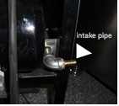
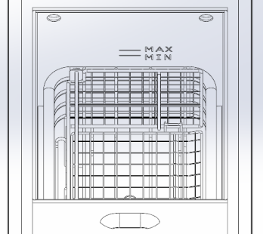

( Figure 1 ) ( Figure 2 )
- Before heating, be sure to add oil first. The oil level must not be lower than the lowest oil level line in the pot (it should be higher than the temperature control probe, as shown in Figure 2) and must not exceed the highest oil level line "-" to prevent the oil from boiling out of the pot after opening the lid and causing danger.
- This machine uses a single 220VAC power supply, and the grounding terminal must be reliably grounded. When multiple machines are used, they must be connected to the same potential to ensure power and personal safety.
- Vibration during transportation may cause parts to loosen or shift. Pay attention to tightening loose parts during installation and commissioning.
- 85kPa when leaving the factory . If the pressure gauge indicates that it exceeds 100kPa (yellow area) and continues to rise, heating should be stopped and the vent valve should be opened to vent air so that the air pressure remains within 85kPa .
- Operation method and production process
- Working principle of combustion control system of gas pressure fryer
This system uses liquefied gas, natural gas, and artificial coal gas as heat sources, and cooperates with a temperature controller and a gas solenoid valve through a special two-in-one gas igniter (normally open flame, thermocouple). The special built-in combustion tube system is electronically ignited, thermostatically controlled, flameout protected, and firepower adjusted to achieve a safe and reliable gas control system.
Its working principle is: the automatic igniter ignites, and transmits instantaneous high voltage to the ignition needle, so that it discharges high voltage through a certain electrical gap, and uses electric sparks to ignite the gas, so that the constant open flame is ignited. Then the thermocouple is heated by the constant open flame, and the thermocouple generates a thermoelectric effect after being heated, so that it automatically opens the gas switch and supplies gas to the burner. At the same time, the constant open flame installed on the combustion tube ignites the combustion tube . When the temperature of the burned furnace exceeds the set temperature, the temperature controller controls the solenoid valve on the gas pipeline, closes the solenoid valve, and the combustion tube stops burning due to no gas supply. When the temperature drops to the set temperature, the temperature control system re-issues a command to open the solenoid valve again, and the combustion tube is ventilated again. The combustion tube is ignited by the constant open flame and starts to burn. This cycle is repeated to achieve the purpose of automatic temperature control.
In order to prevent the danger of gas leakage after the combustion tube is accidentally extinguished, the constant open flame structure can ignite the combustion tube in time . Only when the constant open flame is kept burning, the combustion tube can burn normally. When the constant open flame is accidentally extinguished, the thermocouple cannot be heated, the thermoelectric effect fails, and the intake valve automatically closes to achieve the purpose of safety control.
- Preparation before starting and frying process
- Add oil
Before adding oil, you must open the front door of the machine to check the drain valve and the pump valve to confirm that they are both closed. After checking, close the front door and add oil. Before turning on the control panel, open the upper cover of the machine and add about 25L of liquid cooking oil into the pot ( when adding oil, pay attention to the oil level line "=" in the pot, which should not be too low or too high).
- Ignition
When the manual gas valve is completely closed, the air inlet pipe joint (as shown in Figure 1) is connected to the gas pipeline. After confirming that each joint is well sealed and leak-free, open the gas valve, open the gas valve on the cylinder (Note: use the low-pressure pressure reducing valve on the household gas appliance), wait for a while and then press the electronic ignition button (as shown in Figure 3) . After hearing a clicking sound, it means that the ignition has been started, and the constant flame on the igniter should be ignited. At this time, the thermocouple at the constant flame on the igniter can be heated to keep the constant flame constantly lit. (If the ignition fails once, there will be a fault alarm warning . You can click and press the ignition button again to try to ignite. If the ignition fails to work normally, it means that there is an abnormality in the gas circuit and the ignition device.) When igniting, the oil drain valve and the oil pump valve should be closed.
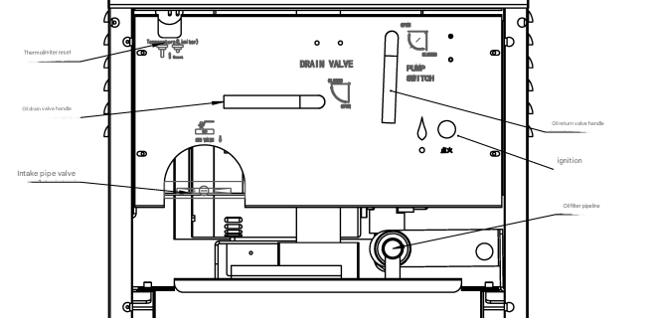

(Figure 3 )

After starting the engine, turn on the power and start the panel to set the program.
- Frying Operation
Turn on the main power switch to "Power". , the panel lights up when it starts. After the panel starts, set the panel program according to the panel settings and operating instructions. After the settings are completed, it is best not to cover the pot when the temperature has not reached the working (frying) temperature. During preheating, use the frying basket handle on the machine to slowly stir the oil in the pot to make the temperature uniform. After the oil temperature reaches the set temperature, the pre-prepared fried food can be evenly placed in the frying frame (this machine comes with 1 frying frame), and the handle rod (frying basket handle) is inserted into the handle interface on the frying frame, and then slowly placed in the pot, remove the handle rod (handle), quickly cover the pot, hook the hook (hook lock), and tighten the fixing screw of the upper cover (the fixing screw must be turned until it can no longer be turned, and the red ball on the handle and the red ball on the hook should be in the same direction). Then press the timing button, the heating in the pot will start to control the temperature to rise, and the screen will start to count down. If the pressure mode is set, the exhaust solenoid valve will automatically close, the pressure in the pot will start to rise slowly, and the pressure indicator on the pressure gauge will rise slowly. When the pressure reaches 85 kPa , the overflow valve will start to open, and the gas will be automatically exhausted to keep the gas pressure constant. When the temperature in the pot reaches the set temperature, the temperature controller will control the solenoid valve on the gas pipeline, close the solenoid valve, and the combustion tube will stop burning due to lack of gas supply. When the temperature drops to the set temperature, the temperature control system will re-issue the command to open the solenoid valve again, and the combustion tube will be ventilated again. The combustion tube will start to burn with the constant open flame , and the cycle will be repeated to achieve automatic temperature control. When the time display decreases to 0, the exhaust solenoid valve will automatically open to release gas, and the frying process is completed. Wait until the gas in the pot is completely released and wait for 30 seconds before loosening the screws on the upper cover, pressing down the crossbeam, lifting the hook by hand, disengaging the hook seat, and opening the pot cover. When opening the cover, the operator is advised to stand in front to prevent hot steam from scalding the wrist. Then lift the frying basket with the handle, hook the hook on the frying basket to the left or right side of the pot, wait for a while, and wait until the food and oil in the frying basket are dripped clean before taking it out of the pot.
Operators must be proficient in operating knowledge and be professionally trained before working to ensure safety. Personnel must not leave the site during production and must monitor the production process in a timely manner. If any abnormality is found, the machine must be stopped immediately to find out the cause and eliminate the fault before operating again.
- How to open and close the pot lid
Turn the tightening handle to the left (loosen) and press the horizontal (large) beam, lift the hook lock handle at the front end, release the hook of the horizontal beam, and then lift the lid. Press the horizontal beam, lock the hook, turn the tightening handle to the right and tighten it with appropriate force, so that the red ball on the rotating rod (handle) is in line with the red ball on the hook lock, which is considered to be sealed.
- Preheating and oil treatment
Because all common vegetable oils (except peanut oil) need to be fried before use, otherwise they will have a raw oil smell, so the oil should be preheated every time you add new oil and fry for the first time (cold pan). In addition, when preheating and treating raw oil, there is no food to be fried in the pan, only a very small amount of water in the oil itself, that is, no water vapor, and the pressure gauge does not increase. Therefore, you should pay attention to the heating time and temperature, and you cannot use the pressure gauge pressure as the standard.
- Oil Filter Procedure
Before filtering the oil, place the oil tank (tank), turn off the main power switch, open the pot cover, take out the frying basket, and it is recommended to wait until the oil temperature is below 120℃ before filtering the oil. Put the filter net prepared in advance (put on the oil filter paper bag outside the filter net and seal it with a filter paper clip), tighten the nut on the oil suction pipe by hand, and then open the oil drain valve to allow the oil to flow out of the pot into the oil tank. After all the oil is put into the oil tank, clean the oil residue in the pot and on the heating pipe, and then close the oil drain valve. Then open the handle of the oil filter valve to the "open" position, and then press the power switch down to the "oil pump " position. At this time, the oil pump starts to pump oil into the pot. Please cover the lid when pumping oil to prevent oil splashing. After pumping oil, close the handle of the oil filter valve to the "closed" position, and then turn off the power switch to the off state (press the switch to the "0 " position) to stop pumping oil. After the remaining oil and oil residue in the oil tank have cooled down, unscrew the nut joint on the oil suction pipe by hand, take out the oil tank, remove the oil filter bag outside the filter screen, clean the residue in the oil tank, and clean the oil tank and oil filter screen for next use.
During operation, be careful to prevent burns caused by excessive oil temperature.
- Machine care and maintenance
      - The overflow valve should be cleaned at least once a day, and the upper screw cover should be unscrewed to clean the specific gravity block to make it jump freely and open and close flexibly. Check the main electrical and power line screws and connectors once a month. If they are loose, tighten them to ensure good contact and sensitive control.
      - At the end of each day's work, the oil stains in the pot and the machine should be cleaned to keep it clean and hygienic and increase the service life of the machine.
      - After the machine has been used for a long time, if the rubber ring is found to be aged and ineffective, it needs to be replaced in time. First, loosen the screws that fix the rubber strips on the four sides of the pot cover, slowly remove the rubber strips from the groove, install the new sealing ring into the groove, and tighten the screws.
      - The machine is equipped with an over-temperature protection device. Once the temperature control fails, when the oil temperature exceeds 230 ℃, the overheat circuit breaker (temperature limiter) will automatically cut off the combustion gas source to ensure safety. The user should check the cause of over-temperature and eliminate the fault. When it needs to be enabled again, the reset button on the "temperature limiter" must be manually pressed to enable it again.
- Combustion system schematic
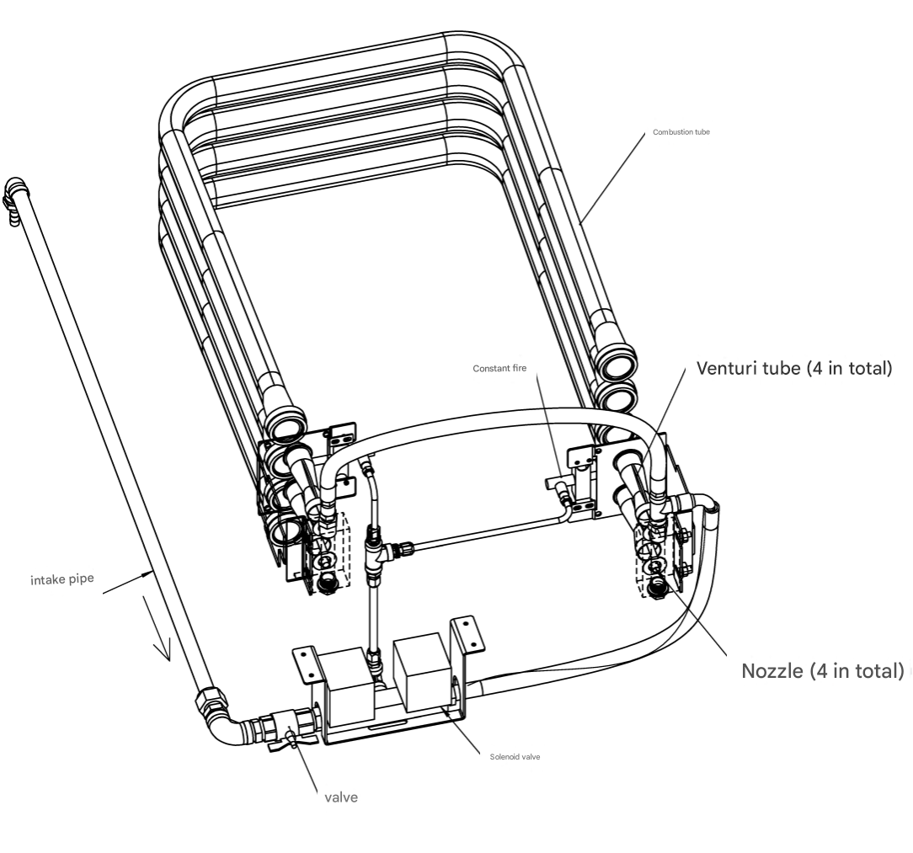

- OFG-5910 panel operation and setting instructions
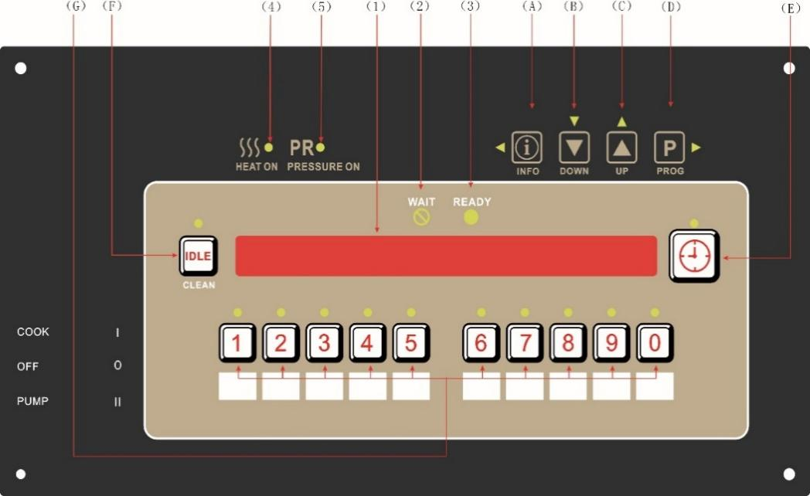
- Operation keyboard panel diagram (see the figure below)

- Display window and indicator light description
Indicator light (serial number) | Instructions
 [1] | Control display window;
 [2] | Wait for the indicator light;
 [3] | Waiting for the indicator light to finish
 [4] | Heating indicator light;
 [5] | Pressure indicator light;
- Function key description
Button (serial number) | Instructions
 (A) | Information viewing key;
 (B) | Parameter setting minus key;
 (C) | Parameter setting plus key;
 (D) | Programming keys;
 (E) | Set the right shift key;
 (F) | When working, long press this button to enter idle mode; when melting oil, long press this button to enter cleaning mode
 (G) | Program Group Key
- Shutdown status
When the controller is powered on, it displays "OFF" to indicate shutdown. When the power switch is turned to the oil pump, the controller displays "PUMP", and the oil pump can be turned on to filter the oil. When the power switch is closed, it enters the startup state, and the controller displays "IS POT FILLED" and "1=YES 2=NO". Is the fryer full of oil? Press the button to select "NO", and the controller displays "TURN OFF UNTIL FILLED". Turn off the controller until the oil is full. Press the button to select "YES", indicating that the heating oil has been filled and can work.
- Melt oil mode


After starting up, if the oil temperature exceeds 110°C, it will directly enter the working mode. Otherwise, it will enter the melting oil mode. In the melting oil mode, the controller displays “MELT 50℃", "50℃" indicates the current oil temperature. At this time, long press any program key to skip the melt mode and enter the working mode directly. The controller displays "EXIT MELT?", "1-YSE 2-NO". Press the key to skip the melt mode, and press the key to cancel it.
- Cleaning mode



In the melting mode, to enter the cleaning mode, long press Press the key to enter, the controller displays "CLEAN- -- OUT?", press the key to enter the cleaning mode, press the key to return to the melt mode. 40℃ 5:00". "40℃" indicates the cleaning temperature, and "5:00" indicates the cleaning time (the cleaning temperature and cleaning time are set by internal parameters SP-7 and SP-8). When the oil temperature reaches the cleaning temperature, the countdown begins. When the time is up, the controller displays "CLEAN DONE” and an alarm will be displayed. During the cleaning process, the cleaning temperature can be temporarily adjusted by pressing the key .
- Working Mode



When the timing is not started, the controller displays "PROG 01 WT 126℃". "PROG 01" is the program name, "WT" indicates that the oil temperature has not reached the appropriate temperature, and "126℃" indicates the current oil temperature. When "RY" is displayed, it indicates that the oil temperature has reached the appropriate temperature. At this time, select any edited program group key ~ , press the button to start the work and enter the preheating stage. The controller displays "PROG 01 PRE 01:00". "PROG 01" indicates the program group name, and "PRE 01:00" indicates the preheating time (for the setting of preheating time, refer to parameter editing PRE LOAD). After the preheating is completed, "DROP" is prompted, indicating that the material can be unloaded. At this time, press the button again to start the timing work. The controller displays "PROG 01 1 01:00". Among them, "1" indicates the first program, and a total of 10 programs can be set. After the work is completed, "AT DONE" is prompted and the controller alarms. At this time, press the button to exit the alarm and enter the quality timing state. The controller displays "QU 01:00", indicating that there is 1 minute left. After the quality time is over, the controller prompts "QU DONE" and alarms. After pressing the button to exit, the controller displays " FILTER: 3 REMIAN ", and "3" means that the oil needs to be filtered after 3 operations. At special moments in the working process, you can set an alarm reminder (see parameter editing ALARM). In addition, you can also perform load compensation for the working time (see parameter editing LOAD COMP).
- Idle Mode
If the idle state is used (see internal parameter SP-4 ) , you can enter the idle mode in a certain working state. "IDLE" is displayed in the idle mode (see internal parameter SP-4A for the idle mode heating temperature setting). When waiting for standby, you can manually press the button to enter the idle mode, or set the time to automatically enter the idle mode in standby, and you can also set it to enter the idle mode immediately after the melt mode ends (see internal parameters SP-4B and SP-4C for details). And enter the idle mode immediately after the work is completed (see parameter editing IDLE MODE for details).
- Oil filter lock
After the oil filter lock function is turned on, when the cumulative number of operations or the cumulative percentage reaches the upper limit, the controller will display the oil filter lock prompt. When the oil filter is locked, when the gear oil temperature exceeds the oil filter temperature, "FILTER LOCK 125℃" is displayed, and "125℃" represents the set oil filter temperature. In the oil filter lock state, the oil filter valve switch must be turned on to filter the oil, and then restart the machine to work normally. The oil filter lock function of each program group must be turned on in the parameter editing FILTER INC or FILER AFTER.
- Information Query

according to Key to view information status
Code | illustrate
"--106 ℃-- " | Actual temperature
"SETPT = 105 °C " | Setting the temperature
" FILTER: 0% USED " | Oil filter reminder remaining cycle
"01:46P WED OCT-06" | Time and Calendar
- Alarm code
Code | illustrate
E-6 TEMP BREAK | Burnout alarm
E-5 TEMP HIGH | Over temperature alarm
E-15 DRAIN IS OPEN | Oil drain valve open alarm
FILTER LOCKOUT | Oil filter lock
FILTER SUGGESTED | Oil filter reminder
CHANGE OIL SOON | Oil change reminder
- ParametersEdit


Press and hold the button for 2 seconds, the controller displays "PROG ENTER CODE" and enters the program group parameter setting by entering the password 123. After setting, press and hold Save and exit (0 ~ 9 groups, press the corresponding program group key to set the parameters of this group).
Code | illustrate
NAME | Program Name
PRE LOAD | Warm-up time
TIME AT | Working hours
TEMP | Operating temperature
PRESSURE | Pressure selection
2 TIME AT … . | A total of 10 programs can be set
ALARM-1 | Alarm prompt
 | Reminder Type
 | Up to 4 alarm types can be set: 5 types of alarms in total
QUAL TIME | Quality time
LOAD COMP | Temperature compensation sensitivity (with LCOMP REF as the reference point, if the actual temperature is lower than the compensation point temperature, the timing will slow down; if the actual temperature is higher than the compensation point temperature, the timing will speed up)
LCOMP REF | Temperature compensation point
IDLE MODE | Whether to enter idle mode when the program ends
FILTER INC | When the oil filter is in GLOBAL mode, set the parameter FILTER INCL to select the number of oil filters; when the oil filter is in MIXED mode, set the parameter FILTER AFTER to select the number of times.
Instant | Instant heating
- Date Settings
Select the CLOCK SET menu and enter the password 123 to enter the time setting . Press the key to adjust, press the key to switch. After setting, press and hold the key to save and exit.
content | Function
C5-1 | years
C5-2 | month
C5-3 | date
C5-4 | Hour
C5-5 | minute
C5-6 | 24-hour system/12-hour system
C5-7 | Second
C5-8 | Week
In the time and date setting, the year, month, day, hour, minute and hour system use flashing to indicate the current parameters. The month codes are as follows: JAN-1, FEB-2, MAR-3, APR-4, MAY-5, JUN-6, JUL-7, AUG-8, SEP-9, OCT-10, NOV-11, DEC-12. The week codes are as follows: MON-Monday, TUE-Tuesday, WED-Wednesday, THU-Thursday, FRI-Friday, SAT-Saturday, SUN-Sunday.
- Oil change reset

Press the and keys to enter the REVIEW USAGE interface for oil change reset. Press the key again to view each cumulative parameter one by one until entering the RESET-USG interface. In this interface, enter the oil change reset password to reset the oil change cumulative parameters and record the date, and then you can start accumulating from the beginning. In the oil change interfaces, press the and keys at the same time to exit. The initial reset password is 123, which can be modified through the internal parameter "SP-12 Modify oil change password".
content | Function
REVIEW USAGE  SINCE NOV-14 | Displays the date of the last oil change reset
PWR ON HRS 6 | Cumulative heating time
TOTAL CK 20 | Cumulative frying time
OIL WEAR 'A' 40% | Oil consumption percentage calculated by cumulative frying time
OIL WEAR 'B' 20% | Fuel consumption percentage calculated by cumulative heating time
USAGE_____ | Please enter the oil change reset password here. The correct password is displayed -USAGE RESET-

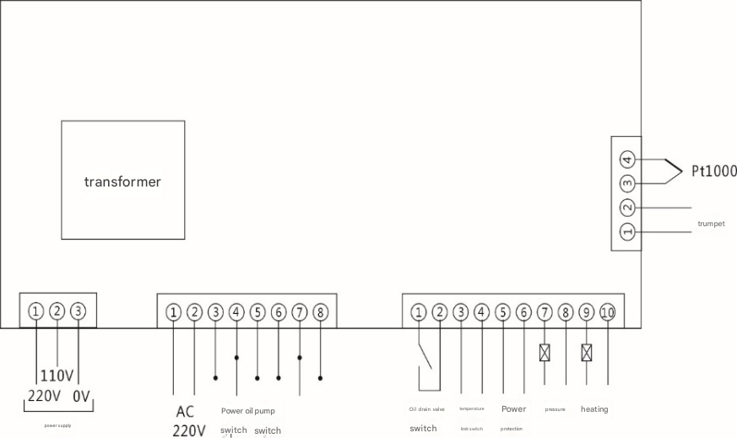
- Wiring Diagram

- Internal parameters

Press and hold the button for 5 seconds, the controller displays L-2, select the PROG menu, and enter the password 123 to enter the settings.
Code | illustrate | Factory value
SP-1 | Select the temperature unit as Celsius or Fahrenheit (℉ or ℃) | ℃
SP-2 | System initialization, press and hold the down key to initialize and initialize internal parameters
SP-3 | Select the melting oil mode, 1-liquid oil 2-solid oil. In the liquid oil option, the heating is on for 12 seconds and off for 12 seconds. In the solid oil option, when the temperature is below 80℃, the heating is reduced to on for 2 seconds and off for 14 seconds. When it exceeds 80℃, the same as liquid oil | SOLID
SP-4 | Enable idle mode. In NO state, there are no following parameters: | YSE
SP-4A | Set idle heating temperature 90 ~ 190℃ (194 ~ 374℉) | 140
SP-4B | Set the automatic entry idle time to OFF ~ 60m, OFF means no automatic idle entry function | 60
SP-4C | Entering idle mode after melting oil | YSE
SP-5 | Select the oil filter reminder mode, there are three situations: 1-OFF means no oil filter reminder or lock function; 2-MIXED means each product sets the oil filter limit separately; 3-GLOBAL means all products set the oil filter limit uniformly | OFF
SP-5A | 2-MIXED: oil filter reminder percentage (75 ~ 100%) 3-GLOBAL: oil filter reminder limit (1 ~ 99)
SP-5B | Enable oil filter lock
SP-5C | 2-MIXED: oil filter lock percentage (100 ~ 200%) 3-GLOBAL: oil filter temperature (120 ~ 190℃ (248 ~ 374℉)
SP-5D | This parameter is available for 2-MIXED, which is the oil filter temperature (120 ~ 190℃ (248 ~ 374℉)
SP-6 | Select the timing start mode, 1-COOK 2-SELECT. In COOK mode, the product key is directly started, and the timing key has no start function; in SELECT mode, the product key only selects the product, and the timing key starts the timing. | COOK
SP-7 | Set the cleaning time, OFF ~ 99min, OFF means turn off the cleaning mode | 10
SP-8 | Set the cleaning temperature to 40 ~ 90℃ (104 ~ 194℉) | 60
SP-9 | When the cooking time reaches or exceeds the upper limit of this parameter, it will remind you to change the oil, the maximum is 5000, OFF means to turn off this function | 1000
SP-10 | When the normal heating accumulated hours reach or exceed the upper limit specified by this parameter, it will remind you to change the oil, the maximum is 999 hours, OFF means turning off this function | 200
SP-11 | Modify the setting parameter password
SP-12 | Modify the oil change password
- Factory parameters:

Press and hold the button for 5 seconds, the controller displays L-2, select the FACTORY menu, enter the password 0005, and press the button to enter the settings.
Code | illustrate | Factory value
F-1 | Temperature correction (-25 ~ +25)℃ | 0
F-2 | Timing PID temperature proportional coefficient (0 ~ 99) | 15
F-3 | Preheat PID temperature proportional coefficient (0 ~ 99) | 35
F-4 | Timing PID operation time (0 ~ 99) S | 0 (=0 for P mode, >0 for PID mode
F-5 | Preheat PID operation time (0 ~ 99) S | 0 (=0 for P mode, >0 for PID mode
F-6 | Timing heating output cycle (0 ~ 99) S | 10
F-7 | Preheating heating output cycle (0 ~ 99) S | 30
F-8 | Minimum value of timing heating output (0 ~ 99) S | 1
F-9 | Preheating heating output minimum value (0 ~ 99) S | 5
F-10 | Timing enters proportional band buffer time (automatically adjusted according to the heating speed, maximum 100%, minimum 50% (1 ~ 99) S | 10
F-11 | Preheating enters proportional band buffer maximum time (automatically adjusted according to the heating speed, maximum 100%, minimum 50%) (1 ~ 99) S | 20
F-12 | Timing advances to the minimum output (0 ~ 99) S | 0
F-13 | Preheating enters the minimum output in advance (0 ~ 99) S | 15
F-14 | Temperature dead zone (0 ~ 10) ℃ | 2

- Electrical Schematics
